DSA0502 – Query Processing for Data Science
Course Faculty | Dr. B .SHYAMALA GOWRI
Reg. No. | 192424050
Student Name | THARUN.V

LAB PROGRAMS 1 AND 2

1. Write a Pandas program to select the distinct department IDs from the employees file.
Aim:
To write a Pandas program to select the distinct department IDs from the employees file.
Dataset :
%%writefile employees.csv
employee_id,first_name,last_name,department_id,salary
100,Steven,King,10,24000
101,Neena,Kochhar,20,17000
102,Lex,De Haan,20,17000
103,Alexander,Hunold,30,9000
104,Bruce,Ernst,30,6000
105,David,Austin,40,4800
106,Valli,Pataballa,40,4800
107,Diana,Lorentz,50,4200
108,Nancy,Greenberg,50,12000
109,Daniel,Faviet,10,9000
110,John,Chen,20,8200

Code:
import pandas as pd
df = pd.read_csv("employees.csv")
print(df["department_id"].drop_duplicates())
Output:
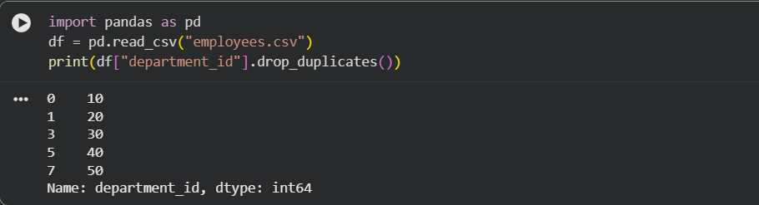
Result:
Thus, the distinct department IDs were displayed successfully.

2. Write a Pandas program to display the IDs of employees who have done two or more jobs.
Aim:
To display the IDs of employees who have done two or more jobs.
Dataset:
%%writefile job_history.csv
employee_id,start_date,end_date,job_id,department_id
101,2001-01-01,2003-12-31,IT_PROG,20
101,2004-01-01,2006-12-31,SA_REP,80
102,2002-02-01,2005-05-31,FI_ACCOUNT,20
102,2005-06-01,2008-12-31,AC_ACCOUNT,90
103,2003-01-01,2007-01-01,IT_PROG,30
104,2004-02-15,2008-06-30,SA_MAN,80
105,2001-01-01,2004-12-31,ST_CLERK,50
105,2005-01-01,2009-12-31,SH_CLERK,50
106,2006-01-01,2010-12-31,PU_CLERK,40
107,2005-03-01,2010-05-31,HR_REP,10
108,2007-01-01,2012-12-31,MK_REP,20
109,2006-04-01,2010-12-31,SA_REP,80
110,2002-01-01,2004-12-31,IT_PROG,20
110,2005-01-01,2008-12-31,FI_ACCOUNT,90
Code:
import pandas as pd
df = pd.read_csv("job_history.csv")
result = df.groupby("employee_id").filter(lambda x: len(x) >= 2)
print(result["employee_id"].drop_duplicates())
Output:
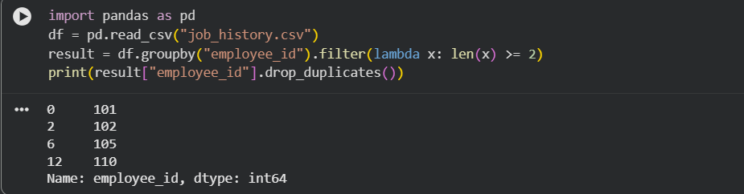Result:
Thus, the employee IDs having two or more jobs were displayed successfully.

